Program Logo

Patient Name:
Date of Birth:

INFORMED CONSENT FOR SILVER DIAMINE FLUORIDE
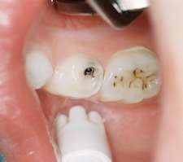
Facts for consideration:
- Silver Diamine Fluoride (SDF) is a liquid that helps stop tooth decay. SDF may be applied every 3, 6 or 12 months.
- A small amount of SDF may be applied to the decayed tooth area.
- After SDF application no eating or drinking for 30 minutes.

Benefits of receiving SDF: Pictures of stain from SDF.
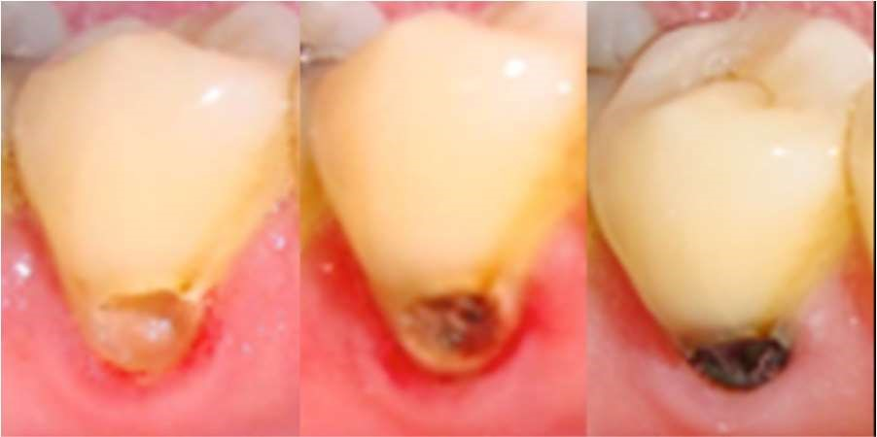
- Helps stop decay.
- Fast.
- Do not need to numb, or drill teeth.
- Does not hurt.
Risks of receiving SDF:
- The affected area will stain black permanently. This means the SDF is working.
- Tooth-colored fillings and crowns may discolor if SDF is applied to them. Healthy tooth structures will not stain.
- If accidentally applied to skin or gums, a brown or white stain may appear that causes no harm, cannot be washed off and will disappear in one to four weeks.
- Could permanently stain clothing dark.
- Might not stop the decay. Additional SDF may need to be applied on a different day.
- After SDF treatment, a filling or crown might still be needed.
- Not all decay can be treated with SDF.

Risk if not treated:
- If decay is NOT treated, it may get worse, and you may lose the tooth or may need more dental work to save the tooth. If not treated, you may experience tooth pain or a life-threatening condition.

I should not be treated with SDF if 1) I am allergic to silver 2) there are painful sores or raw areas on my gums or anywhere else in my mouth.

I HAVE READ AND UNDERSTAND THIS FORM. ALL OF MY QUESTIONS ABOUT TREATMENT, INCLUDING THE BENEFITS, SIDE EFFECTS, AND RISKS WERE ANSWERED.
I consent and authorize _________________________________ to use Silver Diamine Fluoride to help stop tooth decay.
Patient name: _________________________________
Parent/Guardian name: ____________________________________________
Signature: ______________________________________________ Date: ____________

